

The Pitt County Animal Control phone number is 252-902-1725, please contact if needed!

Reference Pitt County Animal Control Ordinance #4 at www.pittcountync.gov/153/animal-services



Christmas Parade

The Town of Grimesland’s Christmas Parade will be held

December 17, 2016 at 2:00 PM

Please come and join in the Christmas fun!!



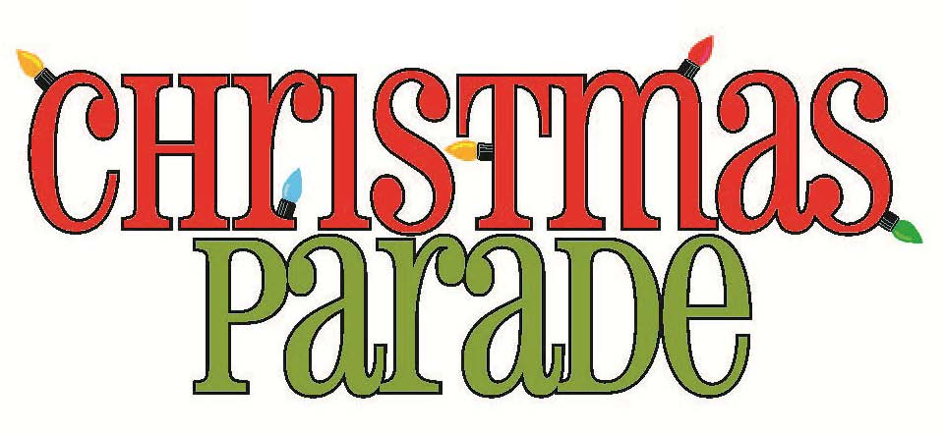



*May Your Holiday Be Merry and the New Year be filled with friends, family and good times.*

*Wishing you a Joyous Holiday filled with Peace, Love and Prosperity. *

*Best Wishes for a Healthy New Year!*

*Town of Grimesland*























Town of Grimesland Website

Please visit the Town’s website and subscribe to receive Alerts by text or email. We will do our best to provide updated information to the community as its happening.

Life Primary Care Clinic, PLLC

Quality Affordable Healthcare

550 River St Grimesland NC 27837

252-758-0602

Hours

Wed. – Friday 9 AM – 6 PM

Saturday – 9AM - Noon



December 2016



Merry Christmas and Happy New Year!!



Happy

Town Hall will be closed December 23rd – 26th. We will also be closed January 2nd for News Years, and also January 16th for the Martin Luther King’s Holiday.

















Town Of Grimesland



**Town - Emergency numbers: Water/sewer outages or problems call: Lee Latham @ 902-4666 & Dan Strickland, Jr. @ 341-7137**

**CALL 811 NOW, DIG LATER. For your info: Utility lines are often buried underground. So, if you are planning to dig on your property, call the NC 811 at least two working days in advance. For more information, visit**

[**www.nc811.org**](http://www.nc811.org)





A Message from the Sheriff’s Office

This Holiday season is a great time to spend quality time with family and make wonderful memories. It’s also the time of year when criminals work overtime trying to be Grinch that stole Christmas. We wanted to give you some safety tips to make you safer this holiday season

* Lock everything
* Secure valuables
* Leave the lights on
* Activate your alarm systems

Always remember, if it doesn’t look right, It probably isn’t. Report suspicious activity to 252-830-4141 and we have a deputy check it out.

From all of us at the Pitt County Sheriff’s Office, we wish you all a Merry Christmas and a Happy New Year!

**Sergeant J.E. Neal**

Pitt County Sheriff’s Office

Community Patrol Division

Field Training Officer

**Pitt County Sheriff’s Office**

**Field Training Officer**

**Office: 252-830-4141**

**Sgt. J. E. Neal**

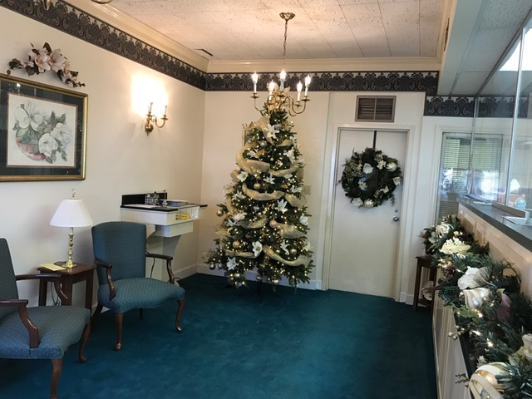

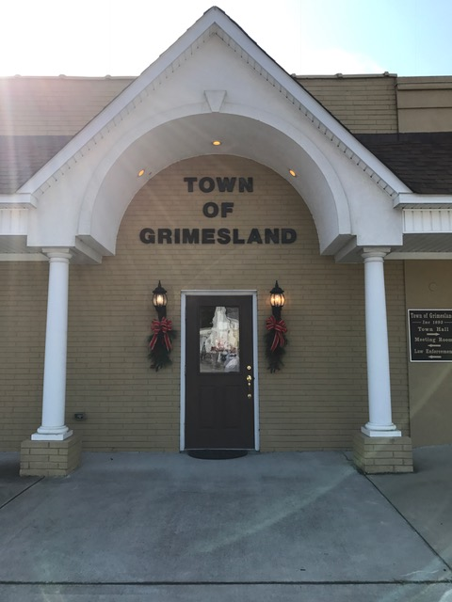

***GARBAGE & RECYCLING:***

***Picked up on Mondays...***

***Have BOTH at the curb by 7 a.m.***

***Town will pick up small limbs if at curbside (must be separate from trash) “just another service provided by your Town at no additional cost to you!”***



**IMPORTANT - SEWER – If the white sewer clean out CAP in your yard is damaged, REPORT IMMEDIATELY so we can replace. This will keep your system working properly.**

***. Please do not put anything in YOUR sewer system – example: feminine products cause major jams in the system.***



**NOTICE**

**Your water / sewer bills are due WHEN RECEIVED. If not paid BY THE 15TH, a late charge of $10 will be added. If not paid IN FULL BY THE 20th of month, your service will be discontinued.**

* **A reconnect fee of $25 if service is cut off – no exception to fee. –**
* **NSF Check Fee is $35!**

**NOTICE: $3 Fee for Credit Card Payment!**

***Town of Grimesland is an equal opportunity employer.***

**BOARD OF ALDERMEN:**

**Mayor ELEANOR FARR**

**(252)758-5549**

**Mayor Pro Tem KYLE HODGES**

**Business Development (252) 916-4642**

**Alderman TOM DIXON**

**Ditches (252) 758-5055**

**Alderman** **GERALD WHITLEY**

**(252) 752-7931**

**Alderman TIM LEACH**

**Parks & Recreation (252) 717-4143**

**Town Hall is open 8:30 a.m. – 5:00 p.m. Monday - Friday**





Town Of Grimesland

Page 2 of 3